

**Implementation Real-Time Schedule Checking and Review System for Online Cinema Ticket Booking Websites**

Written by:

1. Techi Kariska Sari (2320010287)
2. Leann Nataly Kenan Pakpahan (2320010227)

**CEP CCIT**

**FAKULTAS TEKNIK UNIVERSITAS INDONESIA**

**2024**

**PROJECT ON**

**Implementation Real-Time Schedule Checking and Review System for Online Cinema Ticket Booking Websites**

**Developed by**

1. **Leann Nataly Kenan Pakpahan**
2. **Techi Kariska Sari**



**Implementation Real-Time Schedule Checking and Review System for Online Cinema Ticket Booking Websites**

Batch Code : 2SE4

Start Date : June ${15}^{th}$,2024  
End Date : Jully $2^{nd}$, 2024

Name of Faculty : Muhammad Azka Ramadhan, S.Pd., M.BA

Names of Developer :

1. Leann Nataly Kenan Pakpahan
2. Techi Kariska Sari

Date of Submission: Jully $2^{nd}$, 2024

**CERTIFICATE**

This is to certify that this report titled “Implementation Real-Time Schedule Checking and Review System for Online Cinema Ticket Booking Websites” embodies the original work done by Leann Nataly Kenan Pakpahan and Techi Kariska Sari. Project in partial fulfillment of their course requirement at NIIT.

Coordinator:

CEP CCIT



**ACKNOWLEDGEMENT**

We are grateful to Allah, the Almighty God, for giving us the abilities to fulfill our work without incident. Blessings and greetings are also sent to Muhammad SAW, our final and greatest prophet. Not to mention, we are grateful for our parents who have continued to support us both morally and financially till this point. We would like to thank Muhammad Azka Ramadhan, S.Pd., M.BA. as our supervisor who always helps us to finish this paper. Also acknowledged are our friends who have assisted us up until quite recently.

This paper was prepared to fulfill our project assignment as CEP CCIT FTUI students. The topic that will be discussed in this paper mechanism of how Implementation Real-Time Schedule Checking and Review System for Online Cinema Ticket Booking Websites. We hope this paper will be beneficial to all those who read, especially in education of information technology.

The author realizes that this paper is far from perfect, so it will be very helpful if colleagues and supervisors are willing to provide suggestions and criticism for the perfection of this paper.

Depok, July 2024

Authors

y 2024

Authors

**SYSTEM ANALYSIS**

**System Summary**:

The implementation of a real-time schedule check and review system for an online movie theater ticket booking site aims to improve user experience by providing accurate and instant information. The system offers a real-time movie schedule check feature, including seat availability for each screening session. In addition, movie reviews from various sources, including users and critics, are also displayed in real-time with the integration of ratings and comments from third-party platforms. The user interface is designed to be interactive, intuitive and responsive, allowing users to easily access information through efficient search and filter features. Thus, users can make better and faster decisions in booking movie tickets online.

JavaScript as functionalities and CSS were used in the site’s creation to guarantee a seamless and engaging user experience. Visitors can easily access and enjoy the site’s content.

**INTRODUCTION**

In recent years, online cinema ticket booking has become increasingly popular, providing users with the convenience of purchasing tickets from the comfort of their homes. However, despite the ease of access, users often face challenges in checking real-time schedules and reading reliable reviews of movies. Traditional systems may have delays in updating showtimes and may not aggregate reviews from various sources efficiently, leading to frustration and potential misinformation for the users.

To address these issues, we propose the implementation of a Real-Time Schedule Checking and Review System for online cinema ticket booking websites. This system aims to enhance the user experience by providing up-to-the-minute showtime information and comprehensive movie reviews. By integrating real-time data updates and a user-friendly interface, the proposed system will allow users to make informed decisions quickly and accurately. This introduction outlines the motivation, objectives, and key features of the system, setting the stage for a detailed exploration of its implementation and benefits.

**ACTIVITIES LIST**

HTML Project Name : “Implementation Real-Time Schedule Checking and Review System for Online Cinema Ticket Booking Websites”

|  |  |
| --- | --- |
| Date | Activities |
| Saturday ${15}^{th}$ June 2024 | Appoint the Topic |
| Monday ${17}^{th}$ June 2024 | Determine the Layout |
| Wednesday ${19}^{th}$ June 2024 | Creating the Home Section |
| Saturday ${22}^{th}$ June 2024 | Inserting the Film Into the Code |
| Friday ${28}^{th}$ June 2024 | Creating Form Section |
| Monday $1^{st}$ Jully 2024 | Finishing the Word and PowerPoint |

**HTML PAGES**

**Home Page**

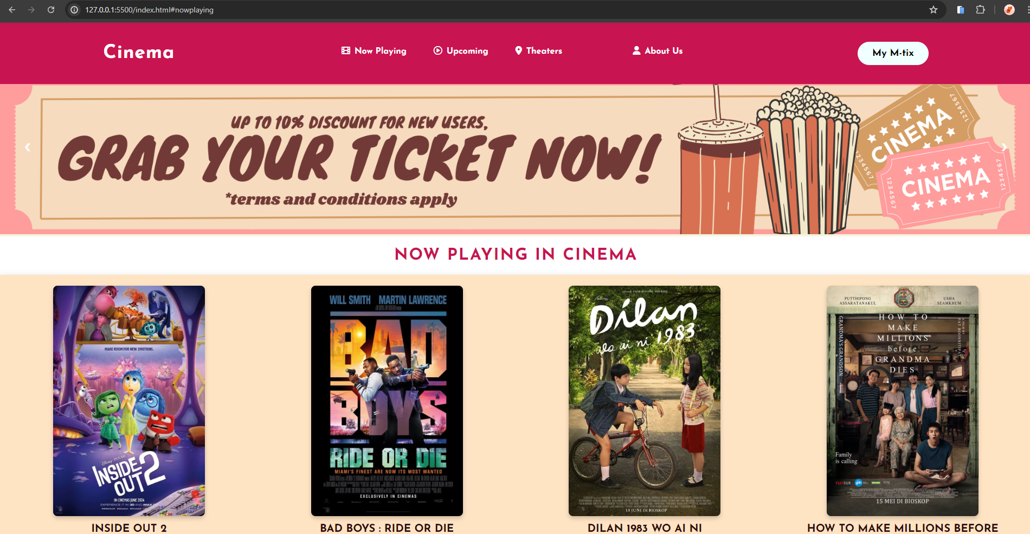

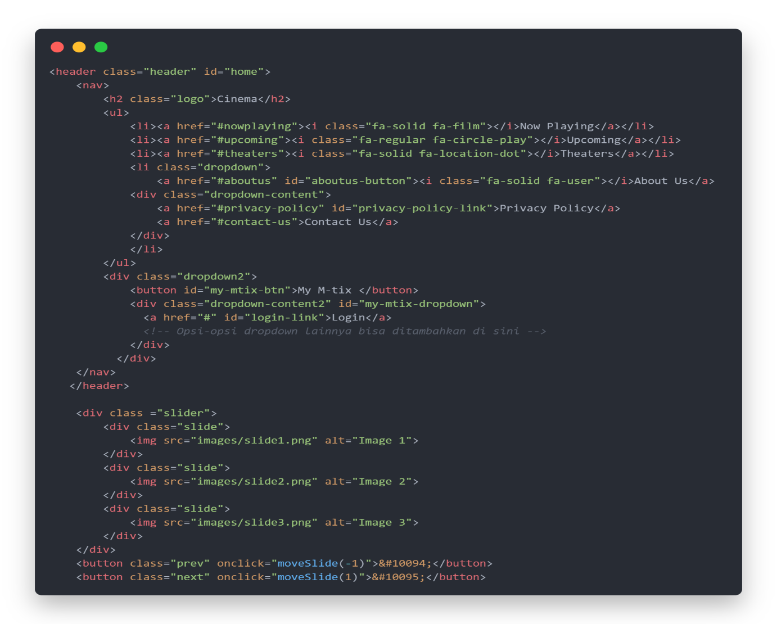

**HTML PAGES**

**Now Playing Page**

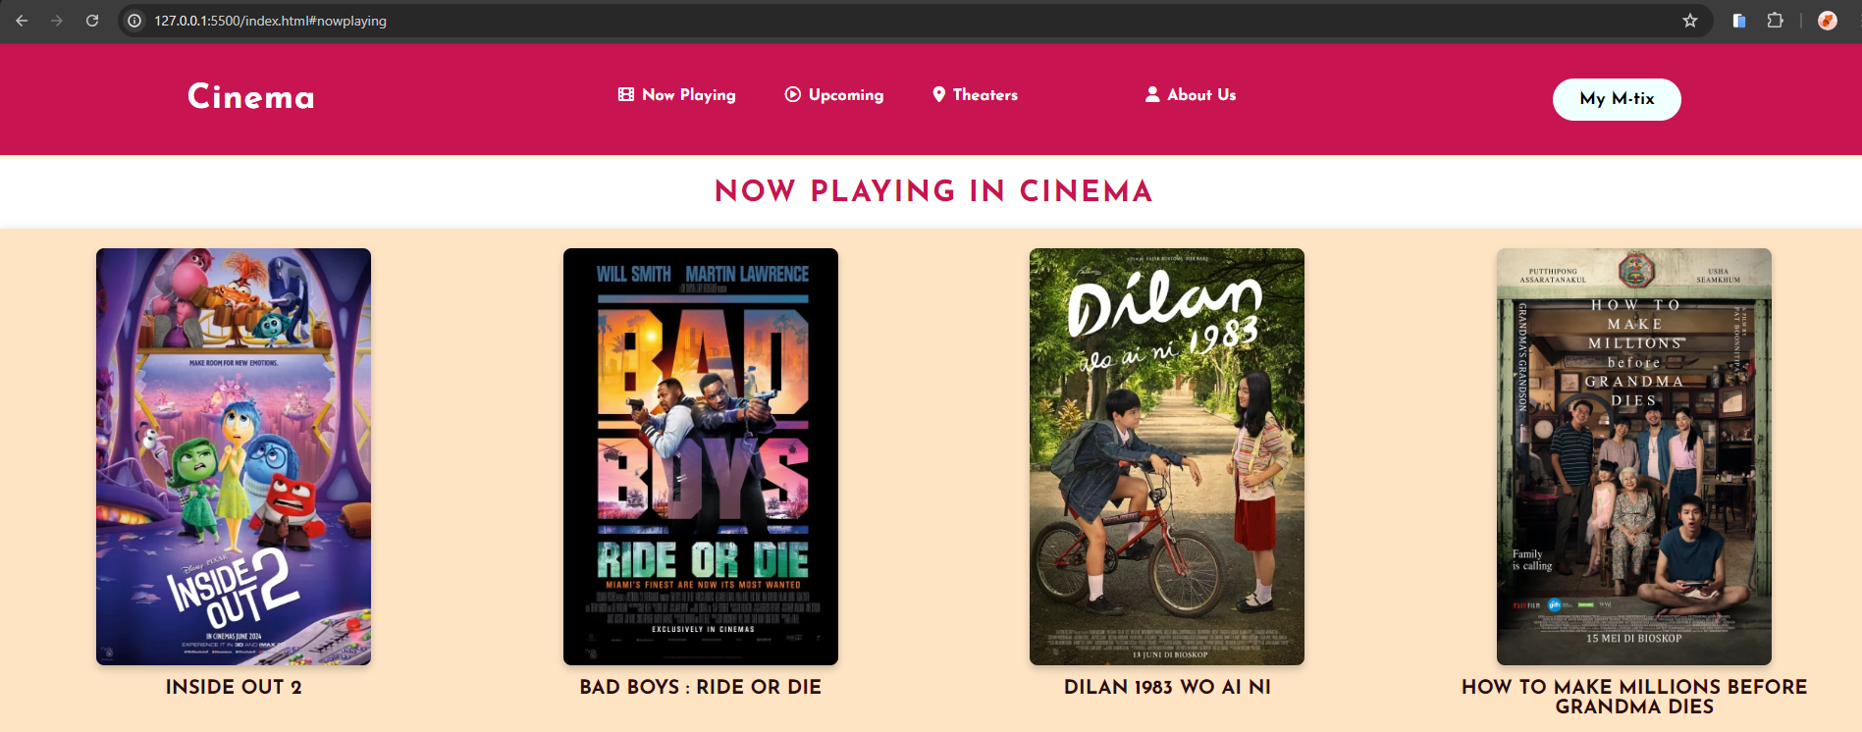





**HTML PAGES**

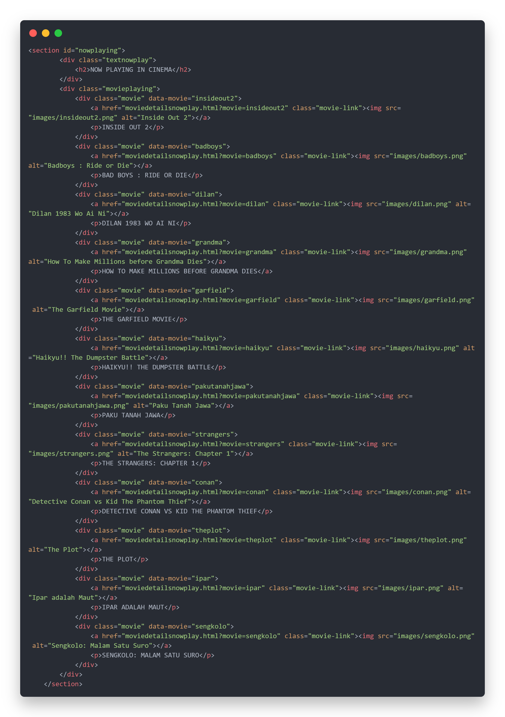

**HTML PAGES**

**Coming Soon Page**

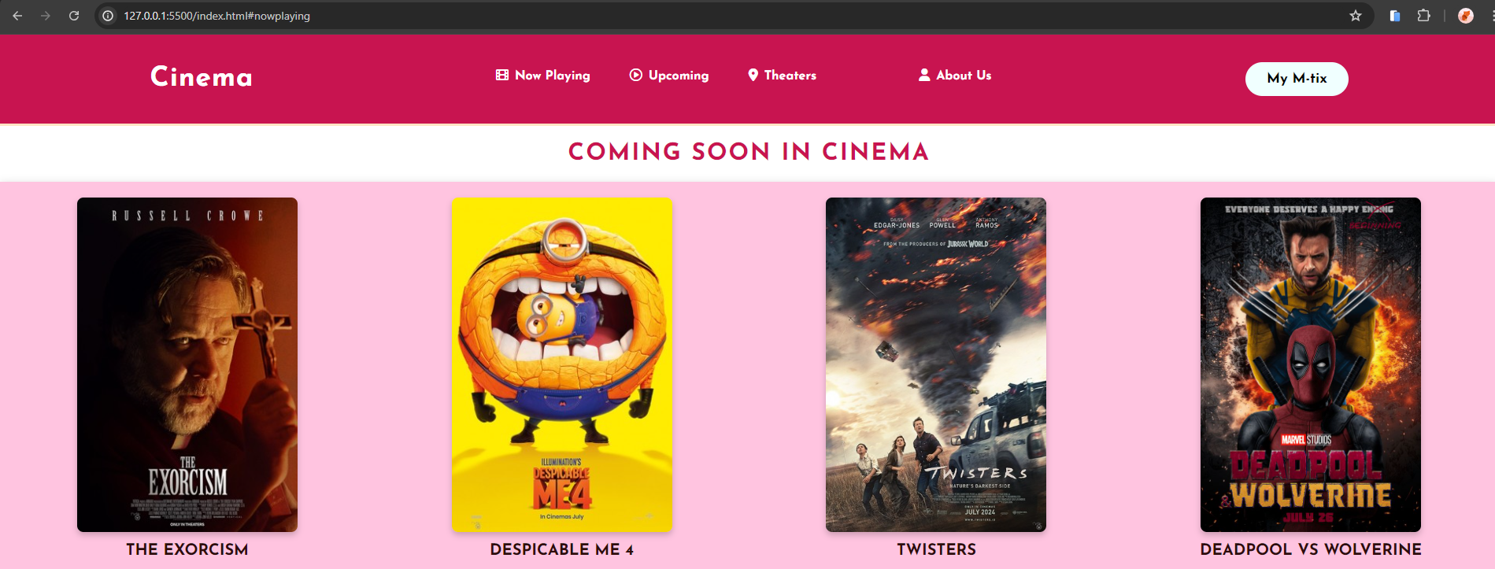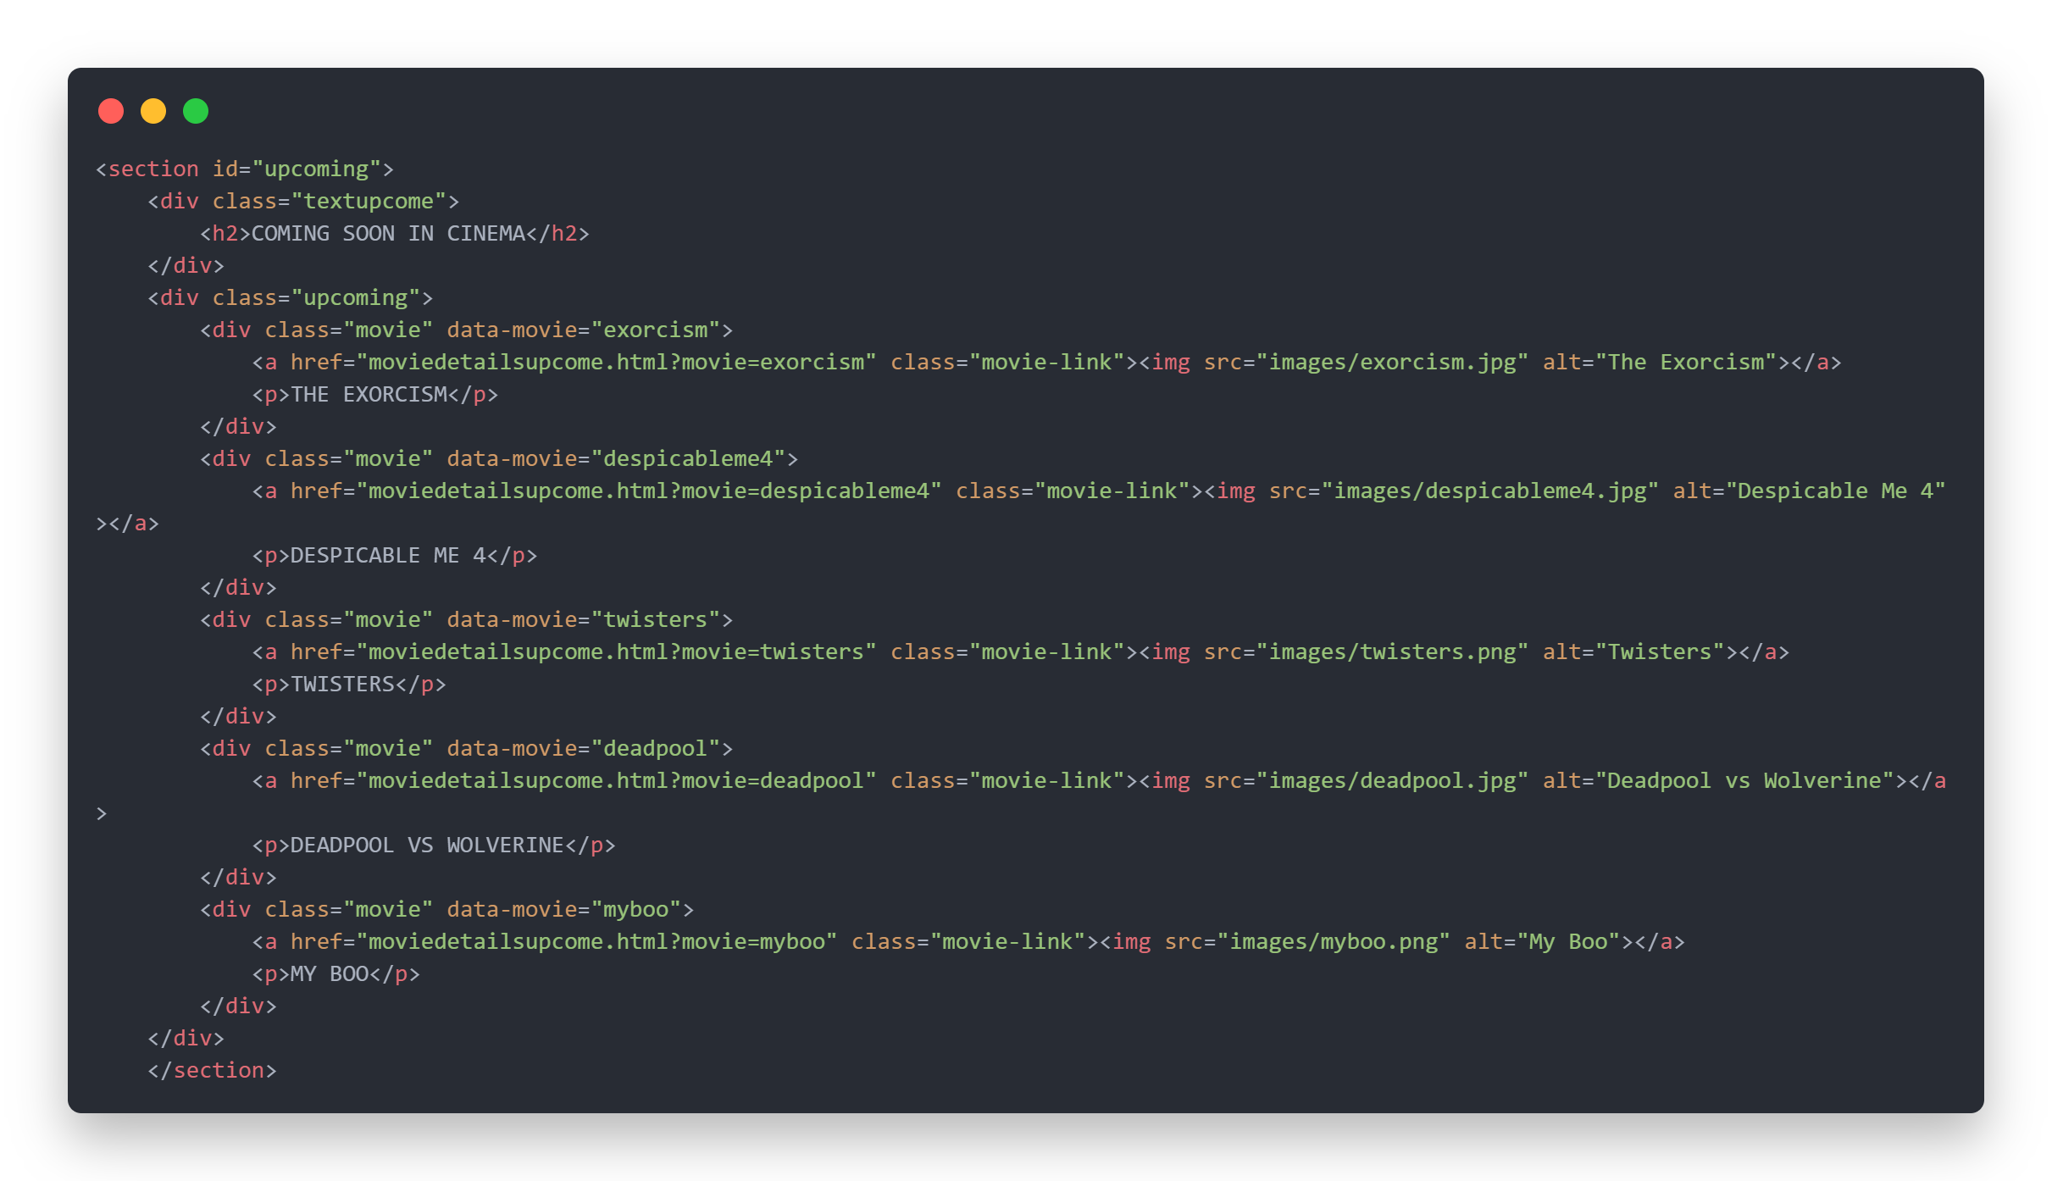

**HTML PAGES**

**Theater Page**

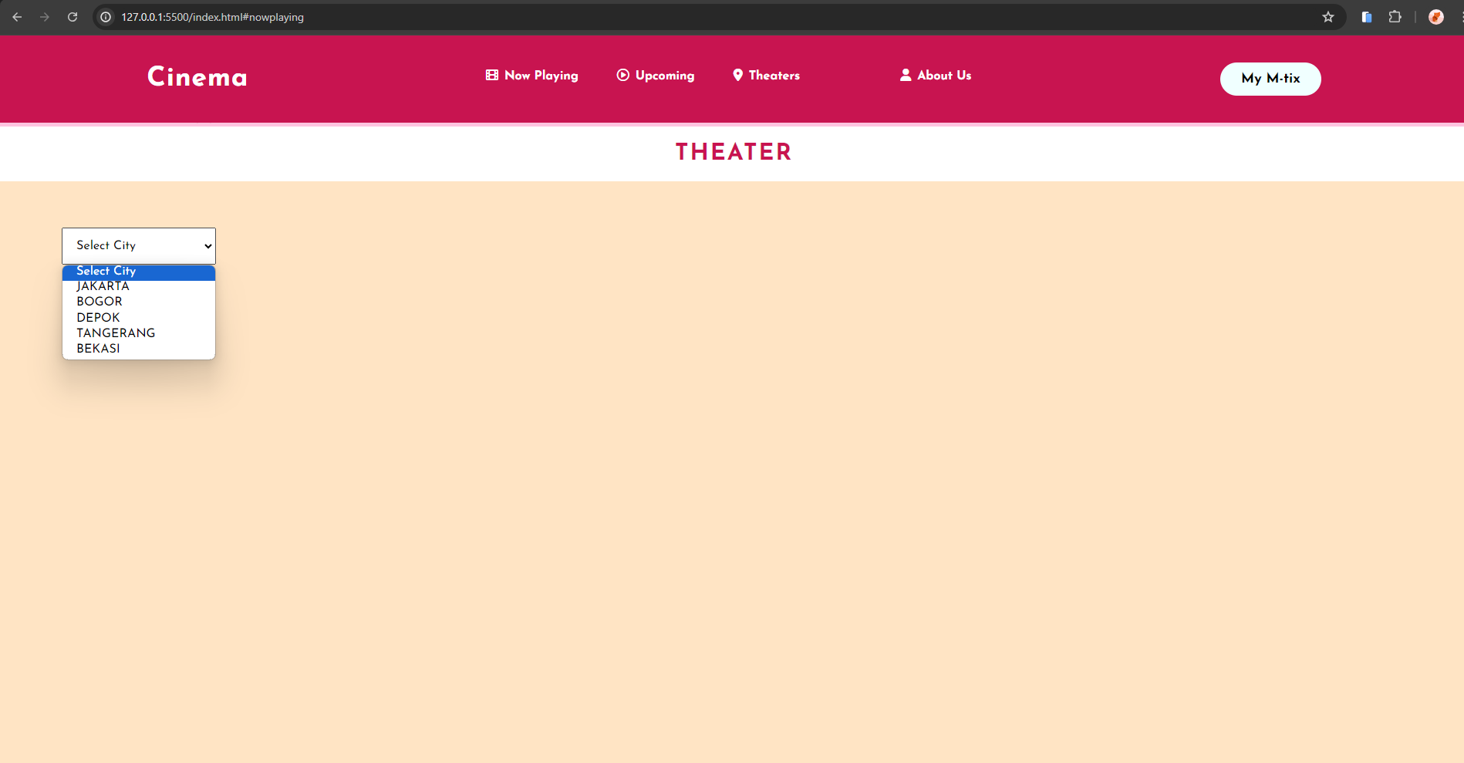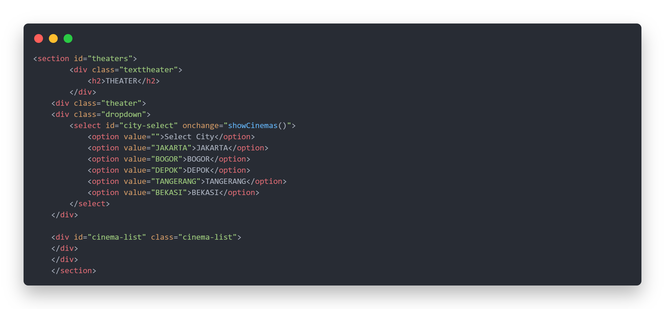

**HTML PAGES**

**Privacy Policy Page**

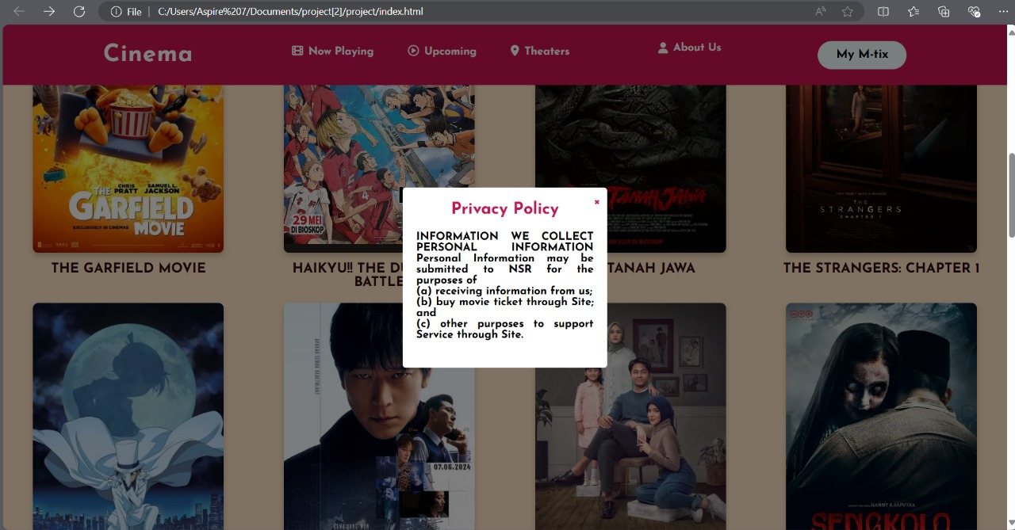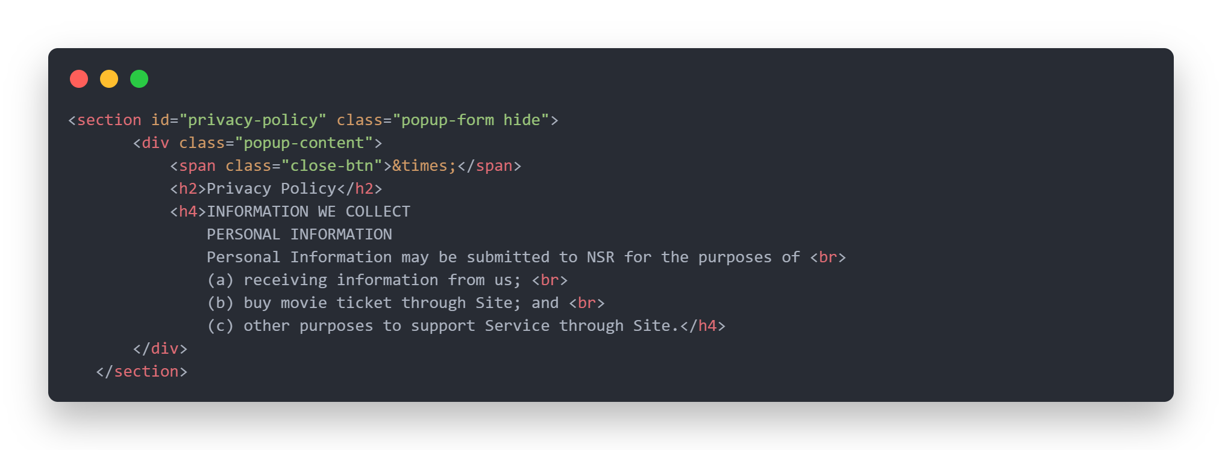

**HTML PAGES**

**Contact Us Page**

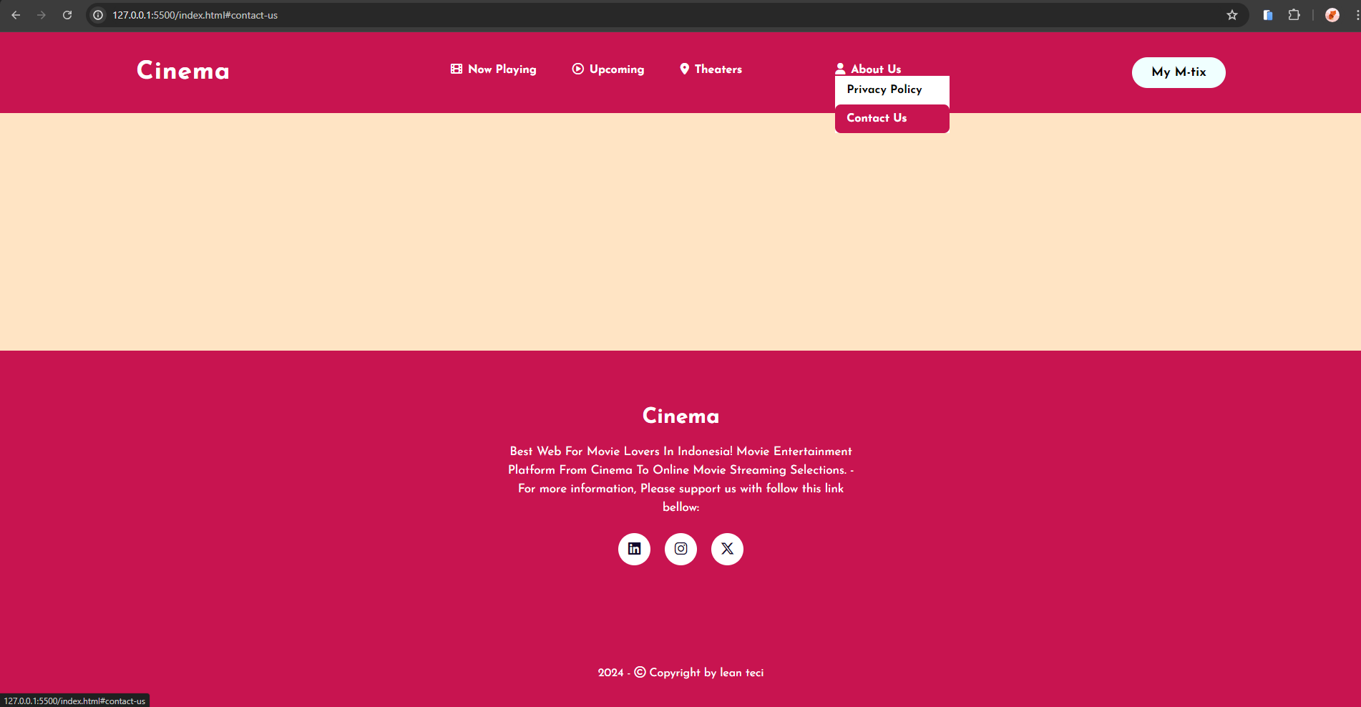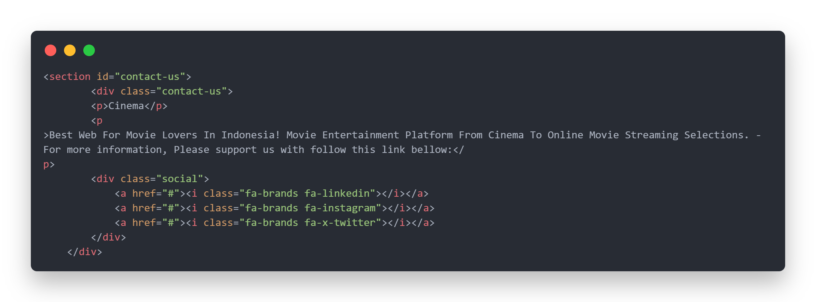

**HTML PAGES**

**Login and Register Page**

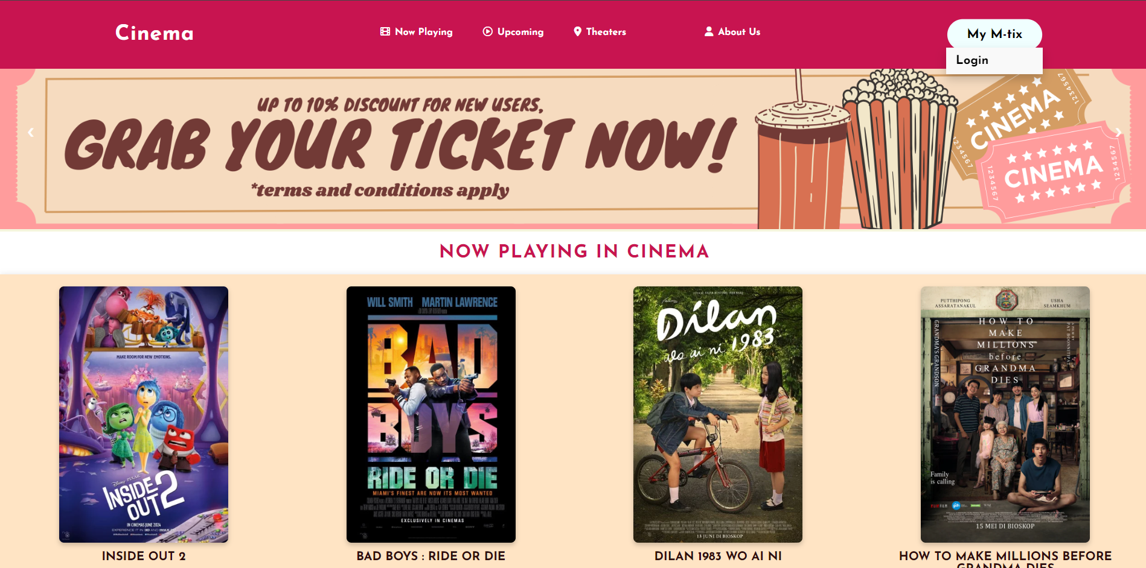



**HTML PAGES**

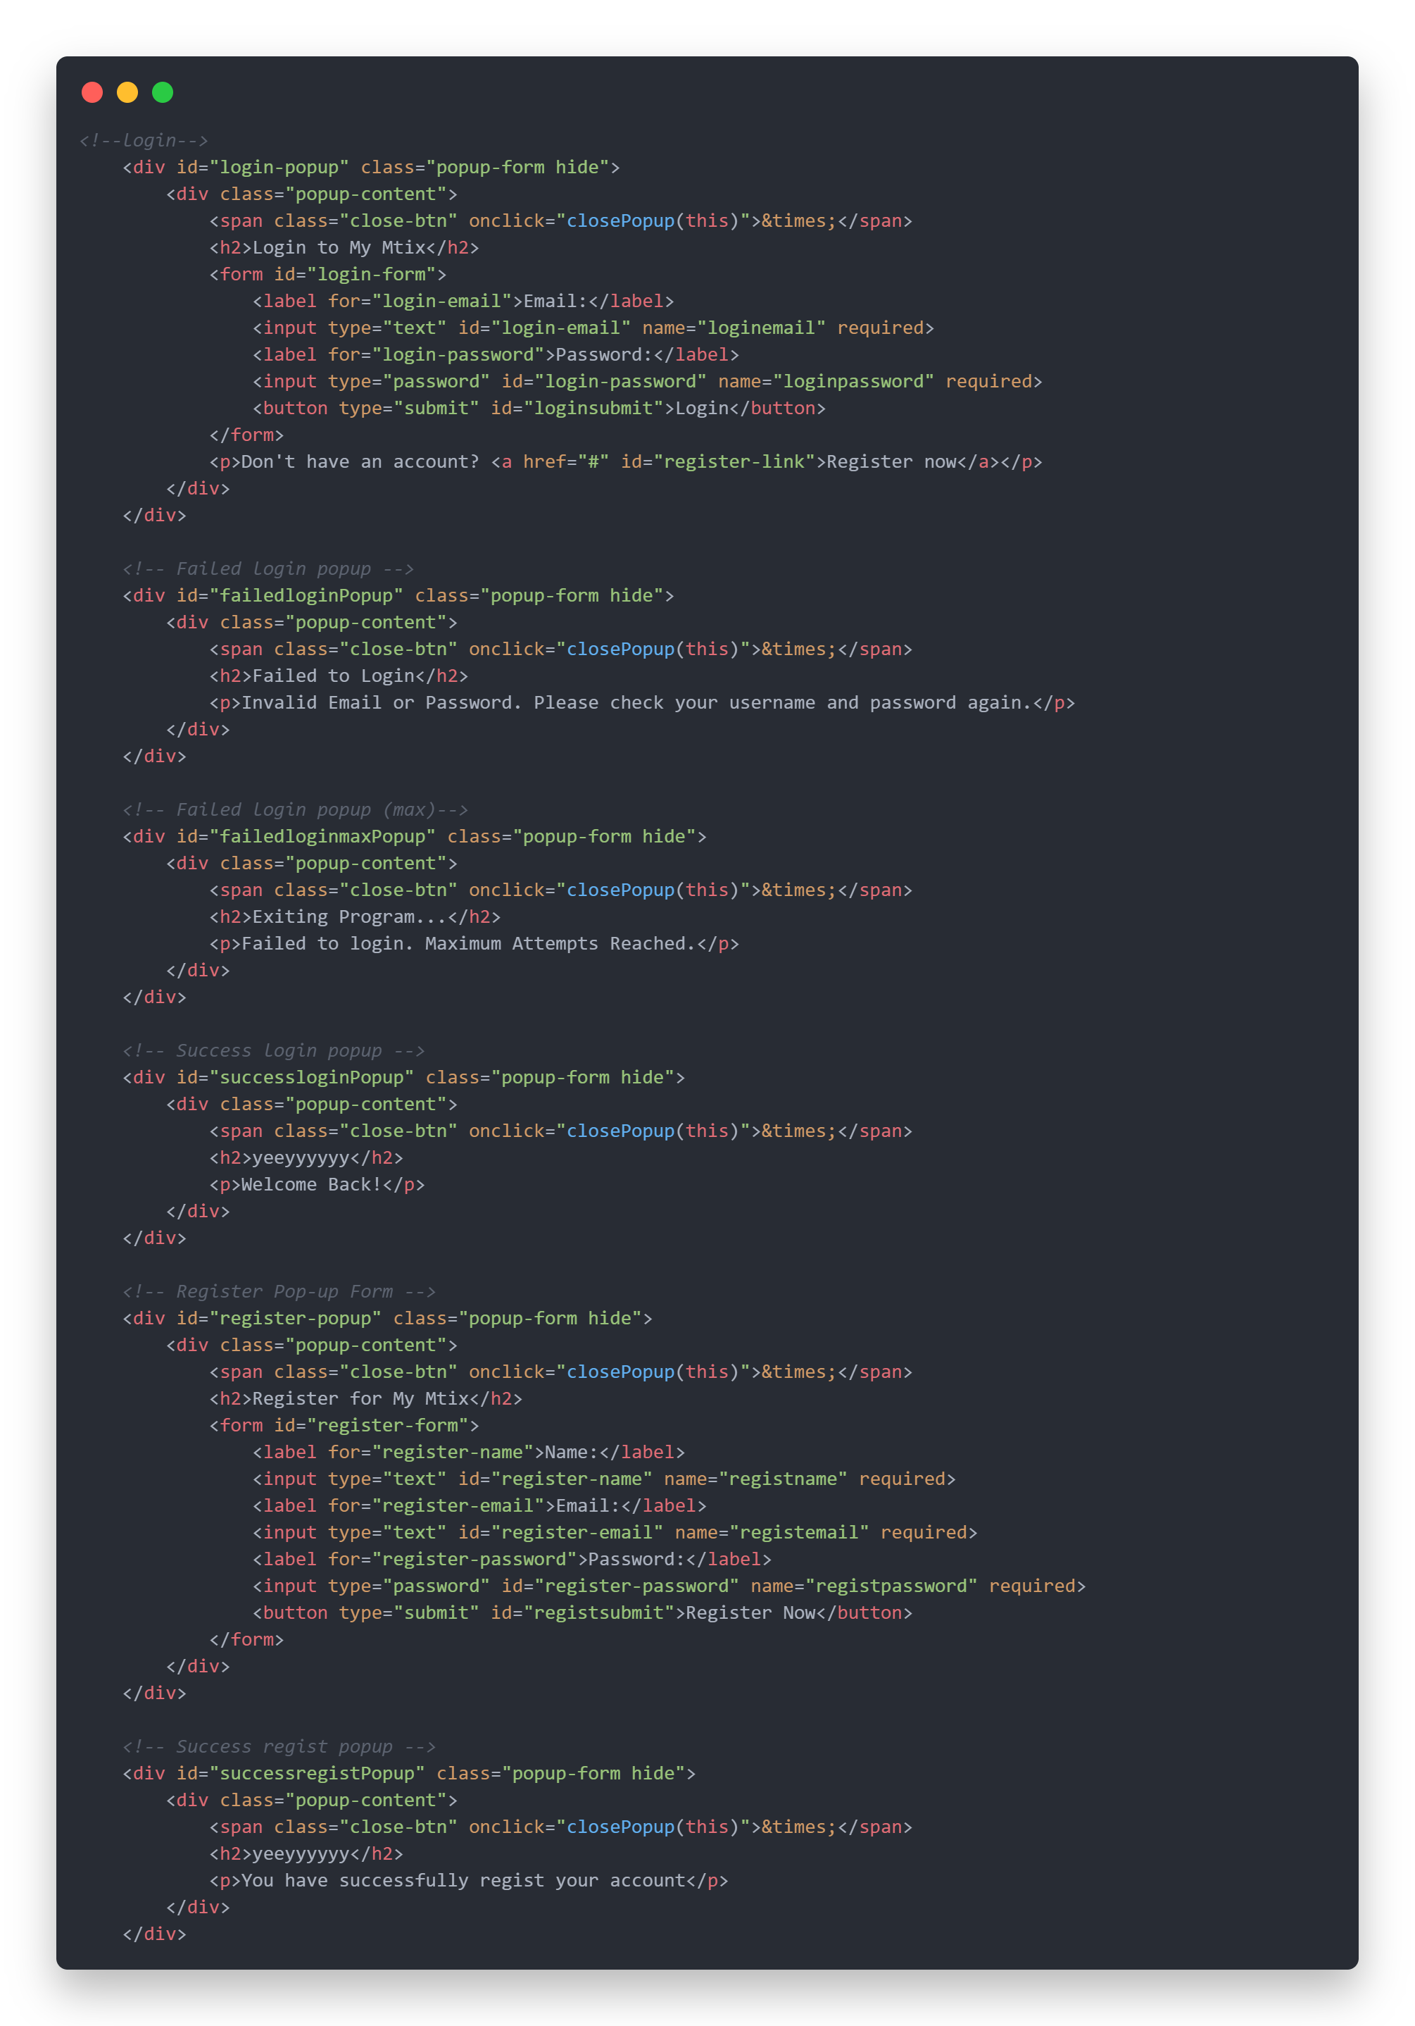

**HTML PAGES**

**Reviews Page**

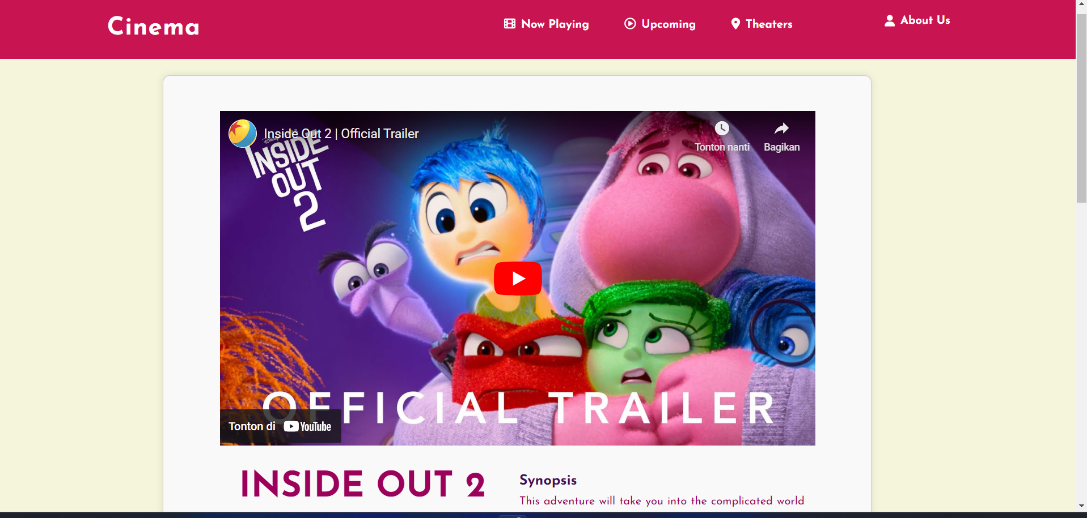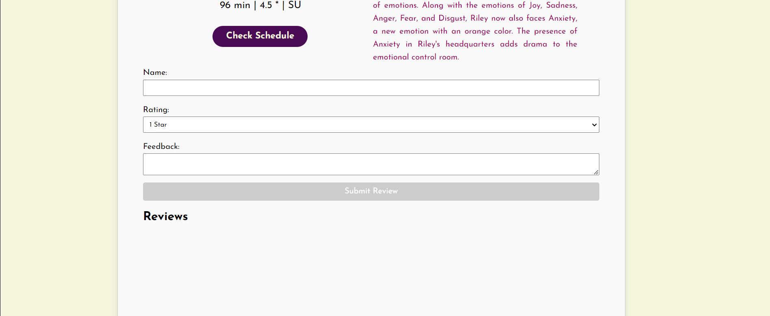

**HTML PAGES**

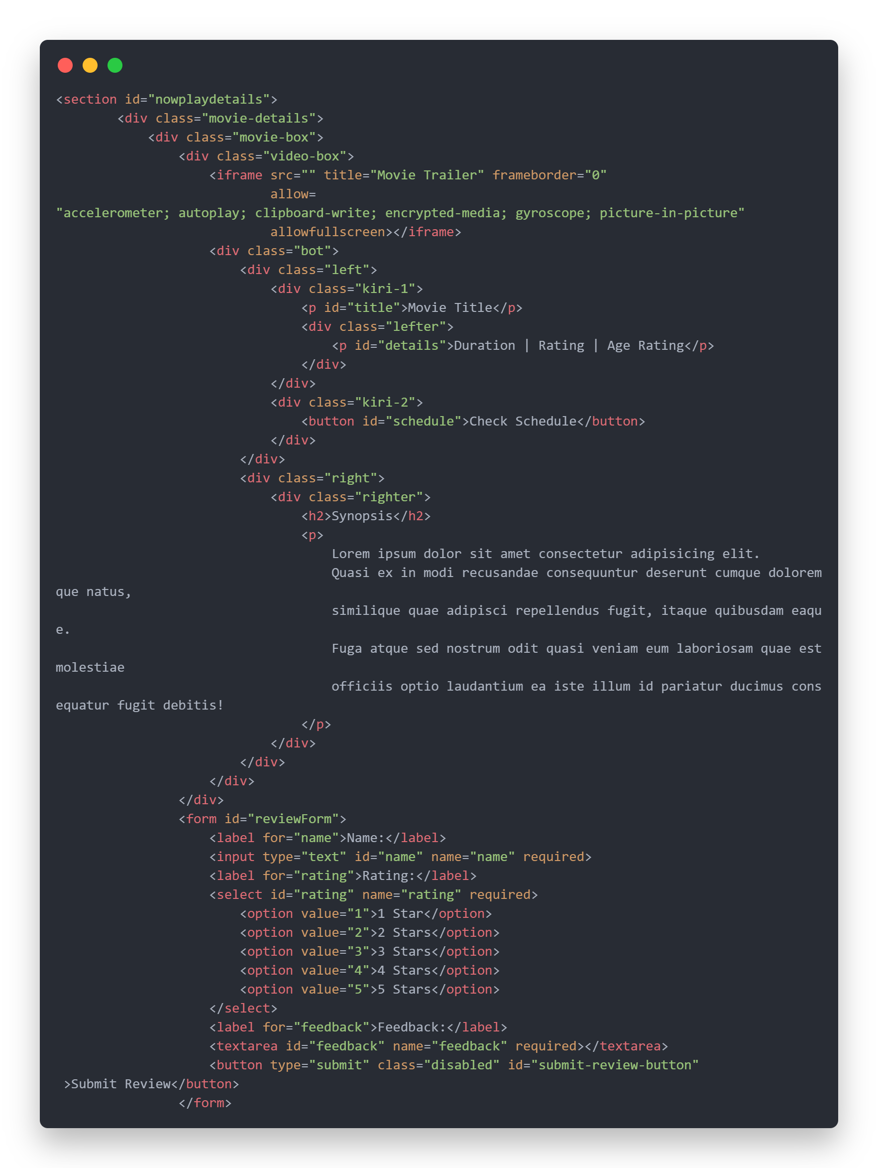

**HTML PAGES**

**Upcoming Details Page**

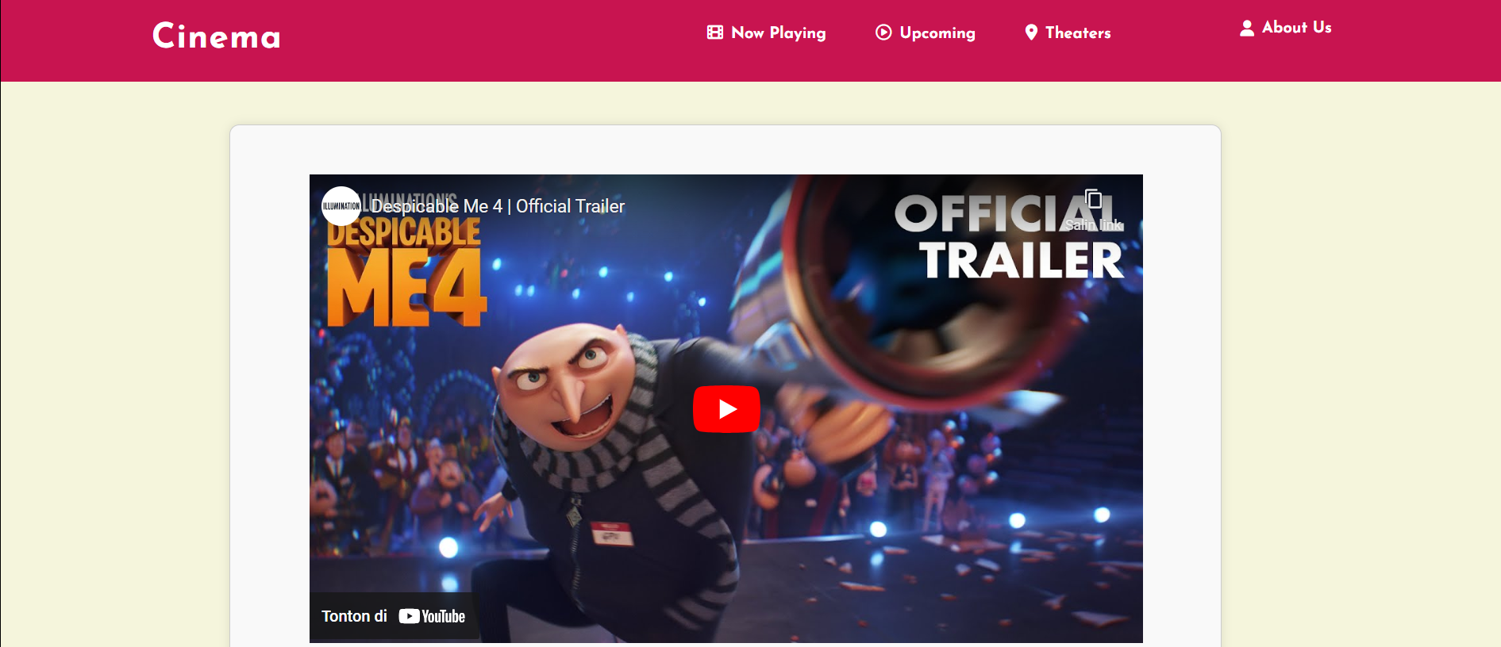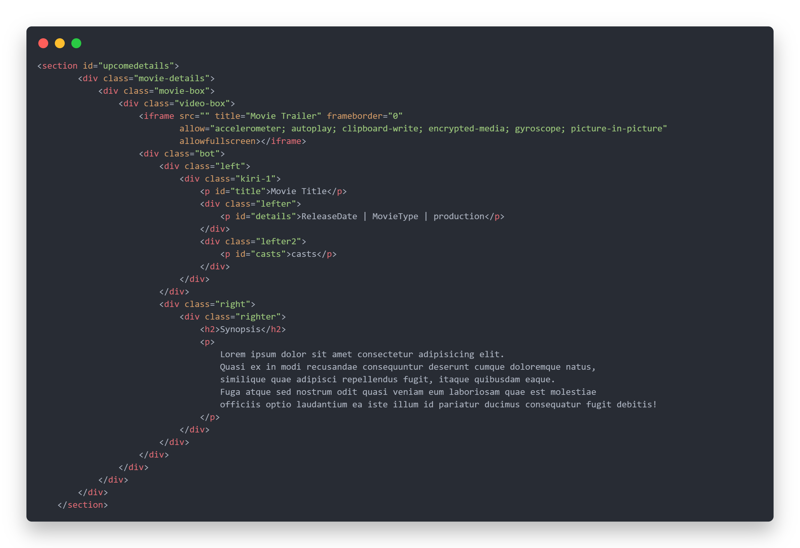

**HTML PAGES**

**Cinema Page**

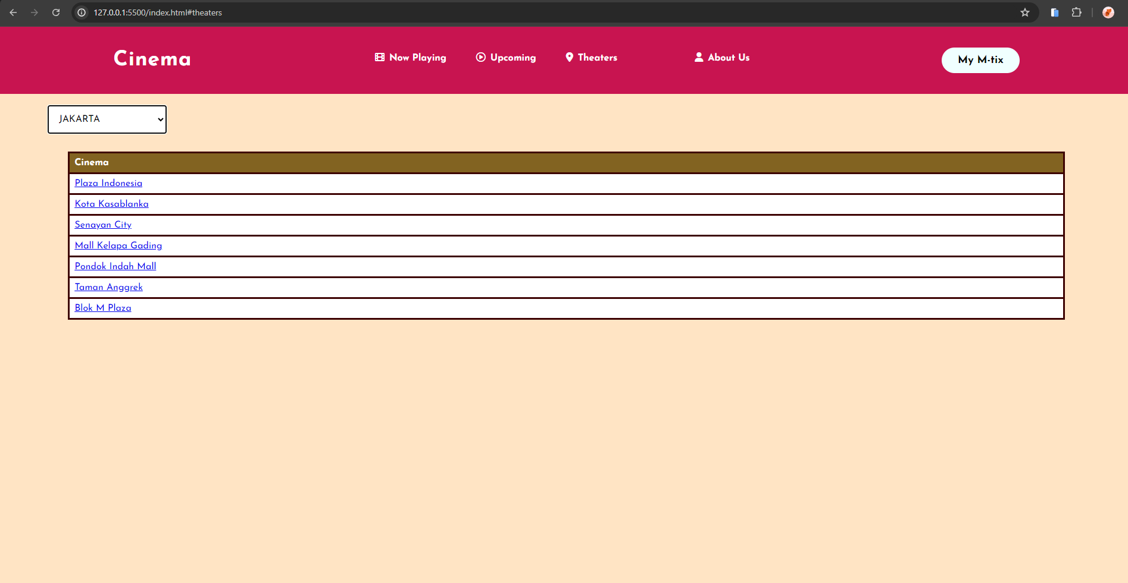

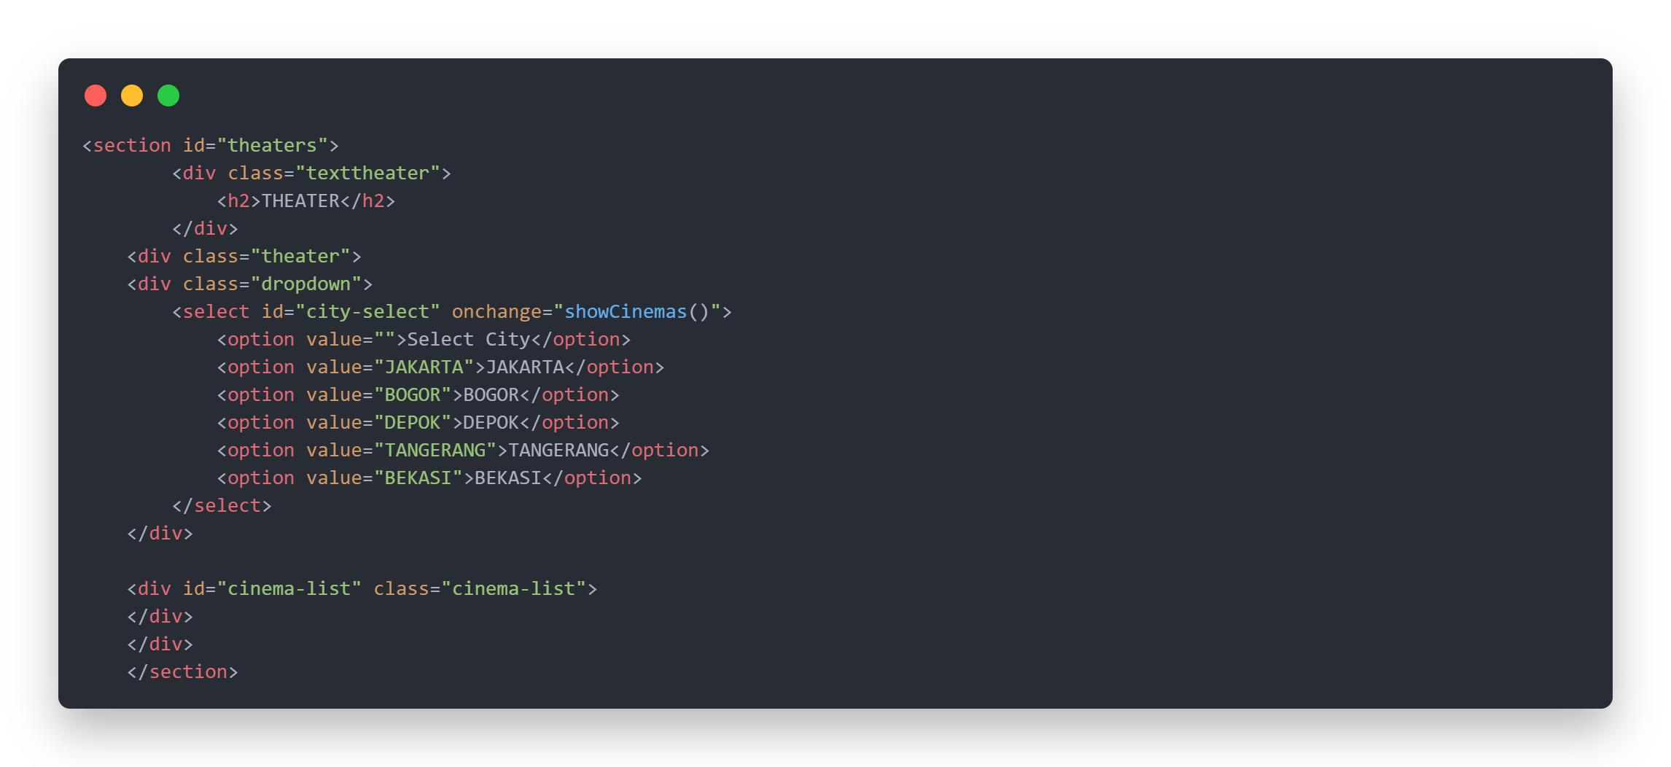

**HTML PAGES**

**Check Schedule Page**

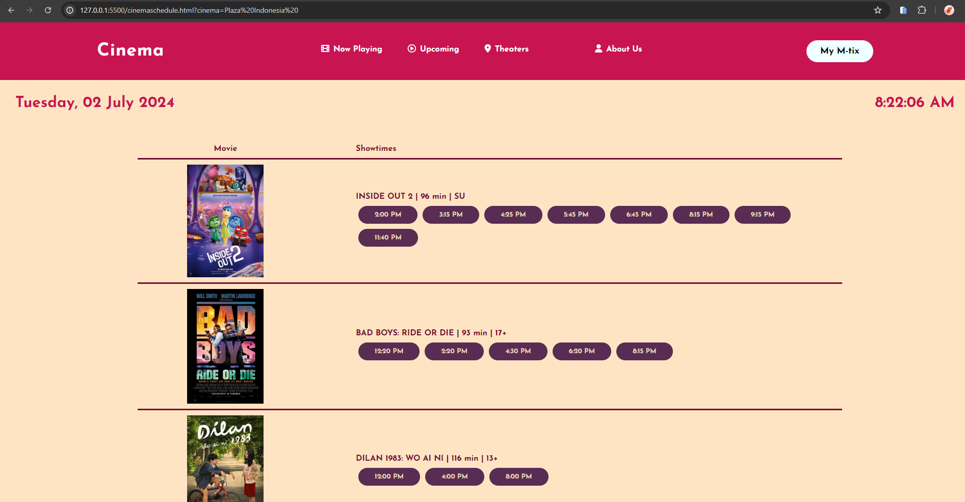

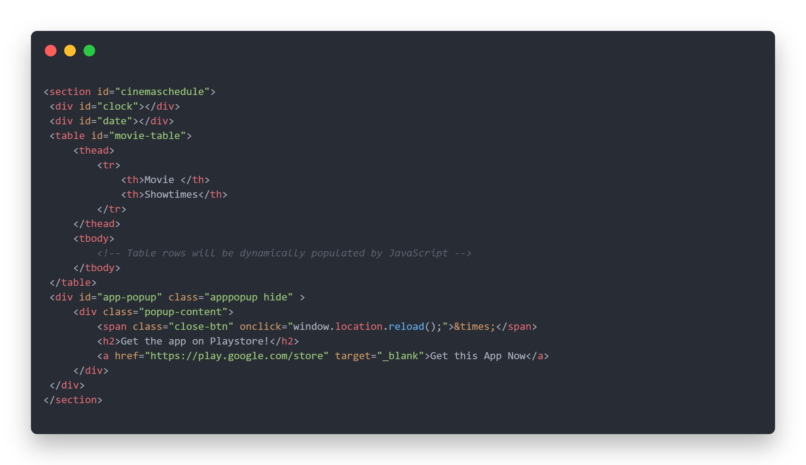

**SYSTEM PROCESS**

**HTML PAGES**

**If click the schedule button.**



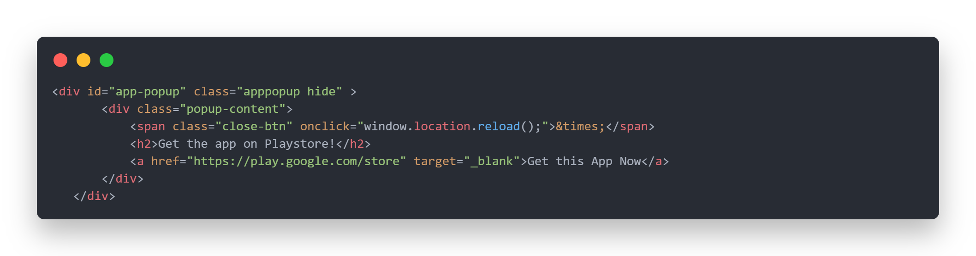

**SYSTEM PROCESS**

**SYSTEM PROCESS**

**CONFIGURATION**

**Hardware :** Acer Aspire A715 – 76G 12th Gen Intel(R) Core(TM) i5-12450H

2.00 GHz 8,00 GB 64-bit operating system

**Operating System :** Windows 11 Home Single Language

**Software :** Visual Studio Code, Microsoft Word

|  |  |  |
| --- | --- | --- |
| **PROJECT FILE DETAILS** | | |
| **No.** | **File Name** | **Remarks** |
| 1. | Badboys.png |  |
| 2. | Conan.ong |  |
| 3. | Deadpool.jpg |  |
| 4. | Despicableme4.jpg |  |
| 5. | Dilan.png |  |
| 6. | Exorcism.jpg |  |
| 7. | Garfield.png |  |
| 8. | Grandma.png | There images are movie poster that is needed for website display. |
| 9. | Haikyu.png |  |
| 10. | Insideout2.png |  |
| 11. | Ipar.png |  |
| 12. | Mtboo.png |  |
| 13. | Pakutanahjawa.png |  |
| 14. | Sengkolo.png |  |
| 15. | Strangers.png |  |
| 16. | Theplot.png |  |
| 17. | Twisters.png |  |
| 18. | Slide1.png |  |
| 19. | Slide2.png | There images are slider for promotion on website display. |
| 20. | Slide3.png |  |
| 21. | Cinemaschedule.html | This file is for see the details of schedule in life-time on website display. |
| 22. | Index.html | This file is for main page of website display. |
| 23. | Moviedetailsnowplay.html | This file is for display the details of movie in now playing section on website display. |
| 24. | Moviedetailsupcome.html | This file is for display the details of movie in upcoming section on website display. |
| 25. | Script.js | This file is for function on this website. |
| 26. | Style.css | This file is for styling on this website. |